**Intern – Research & Development**

**Job Title:** Intern – Research & Development

**Department:** Sales/ Research & Development

**Location:** Chesterfield (St Louis), MO

**Schedule:** Summer 2015; 40 hours per week, up to 350 hours or more (June, July, August), Monday-Friday,

8:00 am – 5:00 pm

**Supervision:**

* Reports to Customer Marketing Manager.
* Works under direct supervision 80% of the time, works independently setting work schedule priorities 20% of the time.
* Does not supervise others.

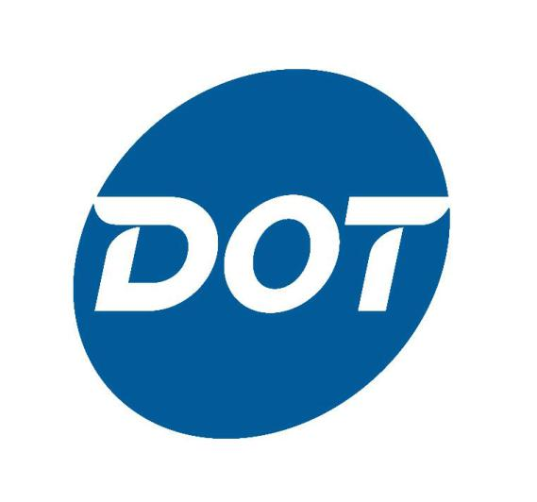

**Primary Purpose:**

This internship position is responsible for training and job-shadowing within various sub-departments in the Sales/ Research & Development areas. It requires learning and understanding tasks within the each area including all components of R & D projects, ongoing research, data sourcing and analysis and how the positions and sub-departments interact with other parts of the business. The position will be responsible for at least one sizeable research project involving internal and external partners and Dot senior management interaction. In addition, the R&D intern is expected to contribute to other projects. Some projects will be one-time activities. Other projects will be ongoing

with varying degrees of frequency. Frequent professional communication and interaction with internal and external customers to complete jobs is required. By the end of the internship tenure, the intern will have completed a minimum of one assigned project for review and possible implementation with the R & D department in addition to gaining valuable professional work experience, knowledge and skills.

**Essential Responsibilities:**

* Training within the sales department and related departments to gain understanding of workflows and business needs in the company.
* Problem definition, research, data collection, analysis to determine best processes and methods for problem-solving.
* Leadership/ ownership of assigned project(s) within the R & D department.
* Create, input, format and update a variety of projects and reports.
* Regular and clear communication with manager and internal and external team members on status of assigned project(s).
* Distribute timely and accurate work.
* Maintain files and generate status information.
* Show professionalism in all skills.
* Job-shadow current R & D staff.
* Participate in a classroom setting and/ or one-on-one training to learn various techniques and functionalities of the R & D area.
* Present project information at the culmination of the internship to communicate research, findings, analysis and any recommendations.

**Occasional Work:**

* Identify areas for improvement within current department processes, set-up
* Internet and phone research, spreadsheet development and maintenance as needed.
* Administrative tasks, other projects as assigned.
* Occasional cross-departmental training and project work with other interns.
* Limited overnight travel for meetings or training

**Safety Responsibility:**

This position assumes responsibility for the workplace safety of self and co-workers, and for the safety conditions of the work location, exercises and promotes safe behaviors and shows unyielding support of programs, rules and policies regarding safety.

**Requirements:**

* Full-time student in good standing actively pursuing a degree, currently completing sophomore or junior year at an accredited college or university.
* Working toward Bachelor’s Degree in a business or related field.
* Minimum cumulative G.P.A. of 3.0 on a 4.0 scale.
* Ability to work up to 350 hours or more during summer, 2014 internship tenure.
* Demonstrated aptitude and experience in computer skills including use and understanding of Microsoft Outlook, Excel, Word, PowerPoint and Access.
* Ability to work independently as well as within a team environment.
* Effective verbal, written and interpersonal communication skills; ability to communicate clearly with various personnel to share/ gather information.
* Effective time management skills to meet deadlines on multiple tasks, projects and priorities.
* Professional and positive attitude.
* Occasional/ limited overnight travel (5-7 nights during summer internship tenure); ability to independently travel without restriction by all modes of transportation, including car, plane or train to attend meetings and training as needed.

**Wage Range:** $8.25 - $12.00 per hour

**Posting:** This information will be posted on company bulletin boards until _______________.

**To Apply:** to apply for this or other open positions, please visit [www.dotfoods.com](http://www.dotfoods.com/) and use the following information:

* Click the ‘Careers’ link box in the middle of the page
* Use the ‘Careers’ link at the top or bottom of the web page or the ‘Search Jobs’ or ‘Log In’ links on the right side of the page (current Dot/ DTI employees, scroll to the bottom of the web page and use the ‘Employee Links’ option)
* If you choose ‘Search Jobs’, you can search all jobs at all locations or search for a specific position by key word, job field, location or organization.
* On the job search page, you can review all the open positions and specific job descriptions and create an application through the ‘Apply’ link on the job postings in which you are interested.
* Once you click on the ‘Apply’ link for a specific position, you will set up a user name and password to start the application process.
* On the job search page, you can create your application through the ‘My Jobpage’ tab or use the Sign In option at the top right of the page or scroll down farther on the page and use the candidate link on the right-hand side of the page to create an application.

**Current Dot/ DTI employees, please note the following:** To apply for this or other open positions, please visit [www.dotfoods.com](http://www.dotfoods.com/) and use the following information –

* Click the ‘Proceed to Dot Foods Homepage’ button near the top of the page
* Scroll to the bottom of the web page and use the ‘Employee Links’ option
* Click ‘Job Postings/ Applications’ under the ‘Employee Links; this will bring up a new page to search for open positions.
* If you have an application/ resume in the on-line application system, please make certain it is updated with your most current information before applying to posted positions.
* Current Dot Foods/ Dot Transportation employees must have manager approval and must meet minimum job requirements before applying to positions.
* open positions. You can search all jobs at all locations or search for a specific position by key word, job field, location or organization.
* On the job search page, you can review all the open positions and specific job descriptions and create an application through the ‘Apply’ link on the job postings in which you are interested.
* Once you click on the ‘Apply’ link for a specific position, you will set up a user name and password to start the application process.
* On the job search page, you can create your application through the ‘My Jobpage’ tab or use the Sign In option at the top right of the page or scroll down farther on the page and use the candidate link on the right-hand side of the page to create an application.

**Current Dot/ DTI employees, please note the following:** To apply for this or other open positions, please visit [www.dotfoods.com](http://www.dotfoods.com/) and use the following information –

* Click the ‘Go’ button under ‘Corporate Information’
* Scroll to the bottom of the web page and use the ‘Employee Links’ option
* Click ‘Job Postings/ Application’ under the ‘Employee Links; this will bring up a new page to search for open positions.
* If you have an application/ resume in the on-line application system, please make certain it is updated with your most current information before applying to posted positions.
* Current Dot Foods/ Dot Transportation employees must have manager approval and meet minimum job requirements before applying to positions.

**This position is open to internal and external applicants. Please contact HR Recruiting/ Staffing with questions.**